MORNING WORSHIP

Prelude
Welcome and Announcements
Apostolic Greeting
*Call to Worship
*Opening Hymn #431
“And Can It Be That I Should Gain”
*Prayer of Invocation
The Lord's Prayer
“Our Father, who art in heaven, hallowed be thy name;
Thy kingdom come, thy will be done, on earth as it is in heaven; Give us this day our daily bread,
And forgive us our debts as we forgive our debtors;
And lead us not into temptation, but deliver us from evil,
For thine is the kingdom and the power
and the glory forever.” Amen.

Word of God 2 Chronicles 34:1-13 p. 400
Pastoral Prayer
The Apostles’ Creed TPH p. 851
*Hymn of Supplication #142
“I Cry for Mercy to the LORD”
Tithes and Offerings
*Doxology #568
Word of God 2 Chronicles 34:14-28 p. 400
Preaching of God’s Word:
“Josiah’s Revival”

*Hymn of Response #243
“How Firm a Foundation”
*Benediction
*Postlude
(*Please stand if able)

Worship Serving Schedule
DATE | USHERS | NURSERY | MEDIA  BROADCAST | COFFEE HOUR  Refreshments
Today | John Hemrick,  Glenn Crothers | HaeSung Keegan | Georgi Kanev | [Luncheon]
NEXT Sunday | Donny Jerie,  Elias Jimenez | Nancy Hemrick | John Hemrick | HaeSung Keegan

AFTERNOON WORSHIP

Prelude
Welcome and Announcements
Apostolic Greeting
Call to Worship
*Opening Hymn #244
“A Mighty Fortress”
*Prayer of Invocation
Word of God 2 Peter 1:1-21 p. 1036
Pastoral Prayer
Hymn of Supplication #434
“A Debtor to Mercy Alone”
Tithes and Offerings
Word of God 2 Chronicles 34:29-33 p. 401
Preaching of God’s Word:
“Josiah’s Reformation”
*Hymn of Response #425
“How Sweet and Awesome Is the Place”
*Benediction
*Postlude
(*Please stand if able)

AFTERNOON SERMON NOTES
2 Chronicles 34:29-33: "Josiah's Reformation"

Main Point: The Word of God is indispensable for the reformation of the church.

- Gather to Hear the Word of God

- Scatter to Practice the Word of God

Sermon

This Reformation Sunday morning in 2 Chronicles 34:1-28, we will learn how a Spirit-produced humility is a prerequisite for spiritual revival in the church.
This Reformation Sunday afternoon in 2 Chronicles 34:29-33, we will see how indispensable the Word of God is for the reformation of the church’s faith and practice.

Announcements

Reformation Sunday Luncheon and Afternoon Worship
Today, we will hold our annual Reformation Day Luncheon in Fellowship Hall in acknowledgement of the history-altering action of a German Augustine Monk & Pastor named Martin Luther, nailing his 95 Theses to the door of the Castle Church in Wittenberg on October 31, 1517.

Keegan’s on Vacation
Next Sunday, November 2, 2025, Pastor John & HaeSung will be on their fourth week of vacation. Mr. JunSuk Seo will be bringing God’s Word in the morning service, and Rev. Young Jae Lee will be preaching God’s Word in the evening worship service.

Next Sunday: The Lord’s Supper
All who may participate in the Lord’s Supper are those who have publicly confessed faith in the Lord Jesus Christ, who continue steadfastly in that faith, who are members of good standing in a particular disciplined and Bible believing manifestation of His Church, and who, in accordance with the Scriptures, have duly examined their hearts before the Lord. If you are a visitor unknown to us and wish to participate in the Lord’s Supper we ask you, if it is possible, to make yourself known to a member of Session before the beginning of worship. The ushers will happily assist you in so doing.

Calendar Events and Notes for this week: see details on the church calendar & bulletin board
- Tuesday – Dinaro Home Group Bible Study
- Wednesday – NO Keegan Home Group Bible Study

MORNING SERMON NOTES
2 Chronicles 34:14-28: "Josiah's Revival"

Main Point: Humility is a Spirit-produced prerequisite for revival in the church.

- Humbly Seek the Lord

- Humbly Serve the Lord

- Humbly Submit to the Word

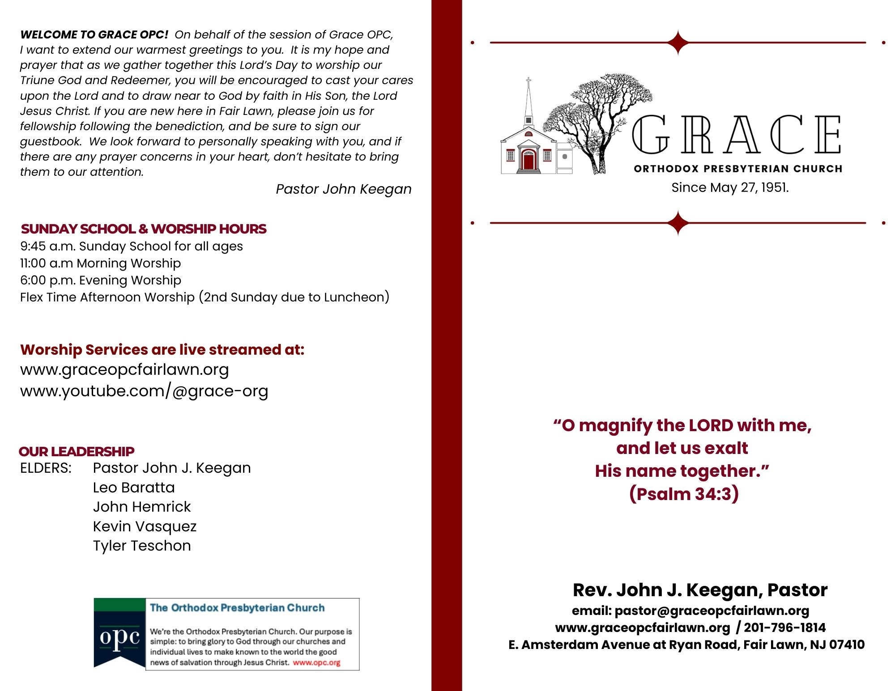
The Lord’s Day Worship
October 26, 2025
Reformation Sunday

